**Test Case 25 – Stacked interior walls with openings**

*Test Description* : A simplified 4-zone model of a building that has interior walls stacked on top of one another. The interior walls each have openings cut into them, to simulate something that may be drawn as a hallway by a designer.

*Space Names:* This is important because the gbXML validator requires the strings in the test file match the standard file. The name check is case sensitive. Ensure that the id attribute of the Space elements in the gbXML test file match the standard file space names shown below.

|  |  |  |
| --- | --- | --- |
| Standard File Space Name | Test File Space Name | Verified |
| sp-1-Space |  |  |
| sp-2-Space |  |  |
| sp-3-Space |  |  |
| sp-4-Space |  |  |

*Special Considerations:*

1. The openings in this test file are defined as Surfaces of surfaceType =”Air”, not Openings.
2. It is common for BIM authoring tools to incorrectly define sliver objects where the thickness of the wall and the air space, commonly defined by a space divider, intersect.

*Complexity of the BIM Model:*

1. Simple planar surfaces orthogonal to the project Cartesian reference frame.
2. Simplified walls with no visible layers.
3. Simple details at interfaces of surfaces.

*Description of Test Case:*

Figure 1 shows a floor plan, highlighting the location of the interior walls and the location of the hole in the interior wall. Dimensions are provided. Figure 2 provides a floor plan of the second floor, showing the location of the interior walls on this floor and the location of the hole. All the dimensions shown are necessary to compute the basic geometry of the test case.

Figure 3 shows the height of the spaces and the thickness of the slab elements. The width of the openings in the interior walls is explicitly provided.

Space separator

**N**

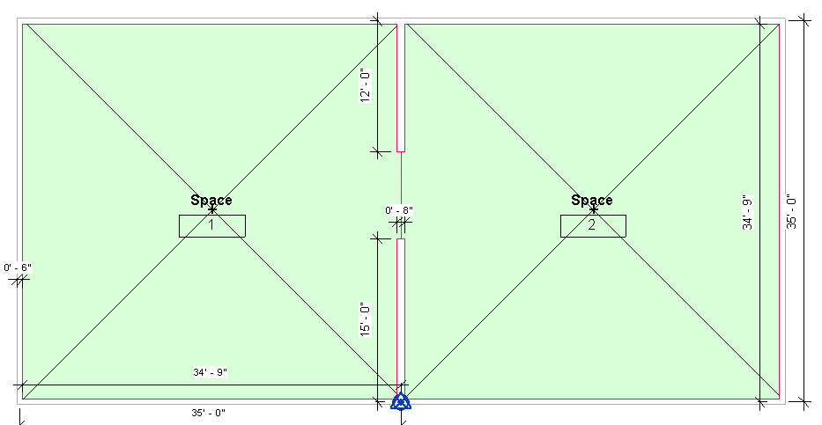

Figure 1: First floor plan view showing the thickness of the exterior walls (6”) and interior wall (8”), as well as the location of the project origin. Each space, measured centerline to centerline, is 35’-0” x 35’-0”. The dimensions of the hole can be determined using arithmetic, but it is also shown in Figure 3 below.

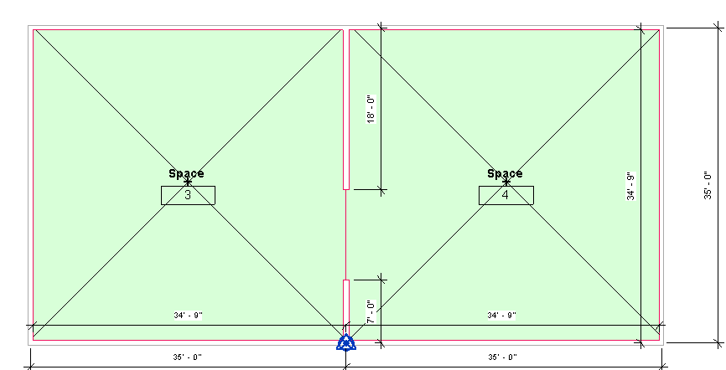

Figure 2: Plan view of second floor. Dimensions and wall thicknesses are identical to the first floor in Figure 1. The relative location of the opening in the interior wall is also shown. The size of the opening could be calculated or is shown in Figure 3.

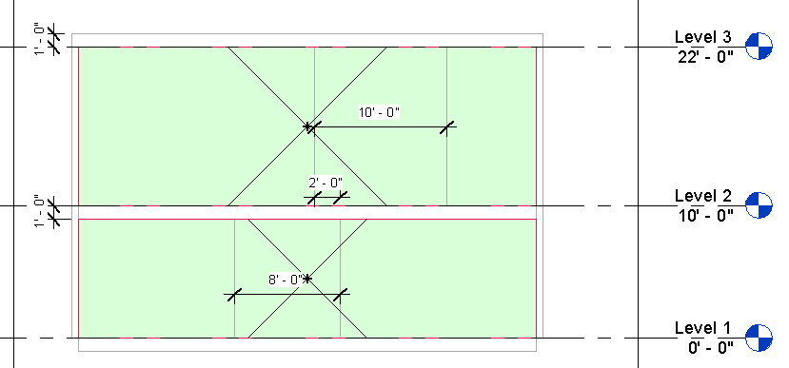

Figure 3: Section looking east, showing the dimensions of the openings, the heights of the spaces, and the thickness of the roof and interior floor. The overlap (2’0”) between each opening is also measured.

|  |  |  |  |
| --- | --- | --- | --- |
| Surface Description | Surface Thickness | Surface Type | Comments |
| Exterior Wall | 6” | n/a |  |
| Roof | 12” | n/a |  |
| Floor Slab | 12” | n/a |  |
| Interior Wall | 8” | n/a |  |

Table 1: Dimensions and descriptions of wall elements in Test Case 1.

*Example of the gbXML Code Relevant to this Example*

We are providing the full code for this example. There are several key issues to consider:

* interior wall slivers are usually created in the areas where the hole (essentially a plane) and the thicker interior wall intersect. Oftentimes, these slivers have PolyLoop coordinates that when analyzed are equal to ½ the thickness of the interior wall and a height equal to the interior wall. It is as if the exposed surface area of the interior wall, created at the interface of the interior wall thickness and the planar opening is modeled as a “new” interior wall. This is an incorrect implementation and will be regarded as such in the validatory.
* it is possible that the floor plate in these spaces will appear jagged (more than 4 sides) because of the difference in thickness between an “air layer” and a solid wall. A validator, when seeking to find a match for this jagged floor
  + in an egg shell model, we are assuming that this jaggedness will not be there. This will cause the gbXML file produced by an egg shell authoring tool to wrongly fail the test. The validator will be updated should this occur.
* the Interior surface that is surfaceType=”Air” is defined by the ShellGeometry, SurfaceBoundary, and Surface elements, as per the implementation guide. Though no actual surface is at the ShellGeometry interface, it is still modeled because the inner wetted surface is only changed into a new surfaceType. The hole does not cause the ShellGeometry to disappear completely. This is true for any Surface whose surfaceType=”Air”.
  + this rule also holds true for egg shell models
* this Test Case does not give clear guidance as to how a wall or opening would be defined if the Opening element had been used to define the hole, with openingType=“Air” in lieu of the approach taken here. This is reserved for a different Test Case.